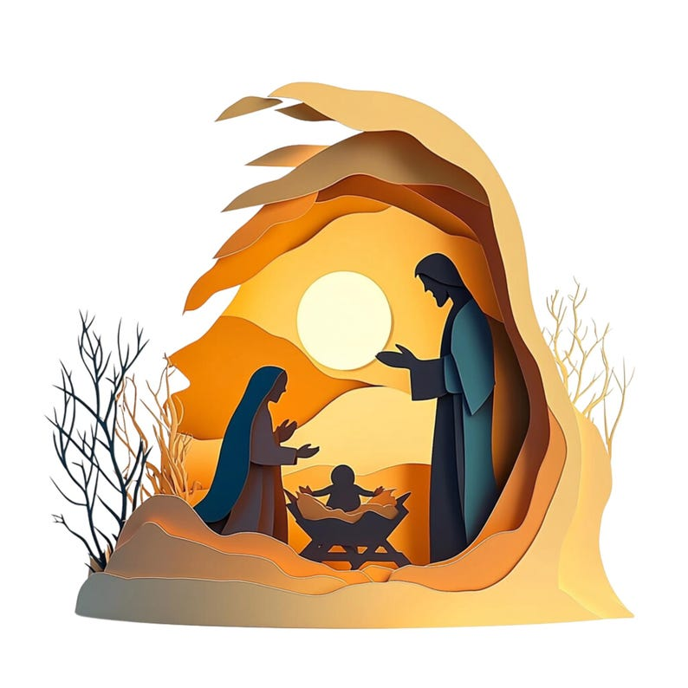

Grace before the Christmas Meal

Lord Our God, the coming of your Son
brings joy to the whole world.
Fill us with your love, And the hungry with good things.
Bless our table and our home
And grant that the food we share increases our eagerness
to serve You in each other. Glory to you, Lord,
In the wonder of your presence among us
For ever and ever.
Amen

